Melinda Chong Hui Ying
Email: melchonghy@gmail.com
Phone Number: +65 9126 3637

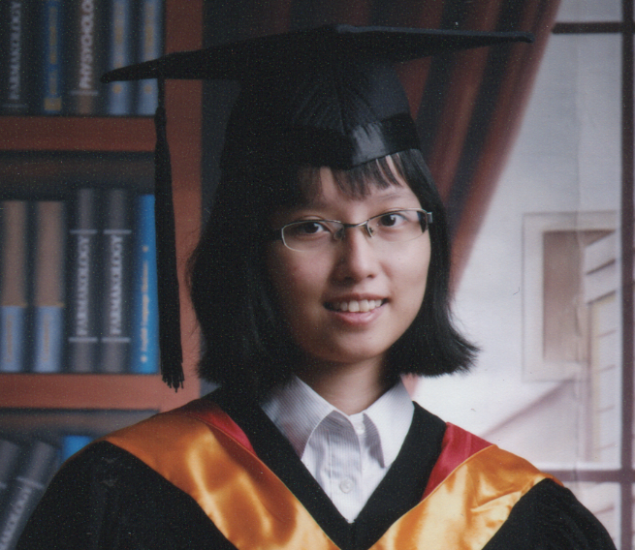
I wish to pursue a career with growing opportunities and challenges in visual art and animation to showcase my craft. I am creative and passionate about developing quirky ideas in a clear dynamic style. I am capable, organised and also look forward to contributing to a team effort.

Software Proficiency
- Adobe Photoshop, Premiere and Audition
- TV-Paint
- NUKE
- Mocha
- Z-brush
- Silhouette

Interests
- Character Design
- Illustration
- Playing the piano

Work Experience

Junior Stereo Paint Artist

Double Negative Visual Effects (Singapore)

2015 – 2016

My role is to create layers from the 2D version of the film for composition of computer-generated effects and conversion into the 3D version of the film. Unfortunately, Double Negative announced that the Singapore office will close in May 2016.

Education

Bachelor of Arts in Animation Art

Second Class Honours (Upper Division)

Goldsmiths University of London (in partnership with LASALLE College of the Arts)
2013 – 2015

Activities Participated:
- 24-Hour Animation Event 2015
- 24-Hour Comic Day 2015
- Designed prospective magazine cover for Campus Magazine’s March 2015 Issue
- 24-Hour Animation Event 2014
- 24-Hour Comic Day 2014

Diploma in Digital Media Design (Animation)

School of Interactive and Design Media

Nanyang Polytechnic
2010 – 2013

Portfolio Link

www.melchonghy.weebly.com

Darn That Little Nuisance!! Production Blog

www.chompymovie.weebly.com

References

Christopher Guy Shaw

Head of Animation at LASALLE College of the Arts

Phone Number: +65 9488 2332

Email: chris.shaw@lasalle.edu.sg

Ang Qing Sheng

Teaching Assistant at Animation at LASALLE College of the Arts

Phone Number: +65 9150 5944

Email: qingsheng.ang@lasalle.edu.sg

Chen Yoke Lin

HR Manager of Double Negative Visual Effects (Singapore)

Phone Number: +65 9225 7567

Email:

